Wildlife Detection Using Detectron2
Youssef Azougagh

Responsibilities:
    - Dataset research
    - Dataset preprocessing
    - Model coding, training, evaluation, and testing
    - Report redaction

Introduction

Computer vision is an essential and rapidly growing field that plays an increasingly important role in many applications, ranging from security and surveillance to medical diagnosis and autonomous vehicles. One of the key tasks in computer vision is object detection, which involves identifying and localizing objects of interest in an image or video stream. Object detection has numerous practical applications, such as monitoring traffic flow, detecting defects in manufacturing processes, and recognizing faces for security purposes.
In this project, we aim to explore and implement an object detection system using the popular Detectron2 library. The primary objective of this project is to detect and classify animals in a given image dataset with high accuracy and efficiency. We will use a deep learning approach and Convolutional Neural Networks (CNNs) to achieve this objective.
Our motivation for this project stems from the need for accurate and efficient object detection systems in various domains, such as traffic monitoring and wildlife conservation. By implementing a robust and effective object detection system, we can improve the efficiency and accuracy of many tasks that rely on object detection, ultimately leading to better outcomes and enhanced productivity.

Related work

There have been numerous studies on object detection and recognition in the past few decades, and many different approaches have been proposed and evaluated. One of the most popular approaches is the deep learning-based method, which uses deep neural networks to extract features and learn representations from raw input data.
One of the earliest and most well-known deep learning-based object detection models is the Region-based Convolutional Neural Network (R-CNN) proposed by Girshick et al. in 2014. R-CNN uses a region proposal algorithm to generate a set of candidate object locations, which are then processed by a convolutional neural network (CNN) to extract features and classify the objects.
Following R-CNN, many variations and improvements have been proposed, including Fast R-CNN, Faster R-CNN, and Mask R-CNN. These models incorporate different innovations such as RoI pooling, feature pyramid networks, and instance segmentation to improve the accuracy and speed of object detection.
Other popular deep learning-based object detection frameworks include YOLO (You Only Look Once) and SSD (Single Shot Detector), which use a single neural network to predict bounding boxes and class probabilities directly from input images and achieve real-time performance on a range of hardware.
In addition to deep learning-based approaches, traditional computer vision techniques such as Haar cascades and HOG (Histogram of Oriented Gradients) have also been used for object detection and recognition. These methods typically rely on hand-crafted features and classifiers and may not perform as well as deep learning-based approaches, but can still be useful in certain applications.

Data

- Data Source and format
The dataset used for this project is a wildlife dataset with pictures of 4 classes of animals (Elephant, Rhino, Buffalo, Zebra). The dataset can be found on Kaggle database[2].
The dataset contains 376 images from each class with their annotation files for a total of 1504 images with their annotation files.

- Data example

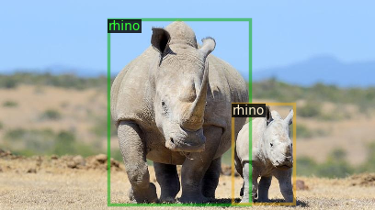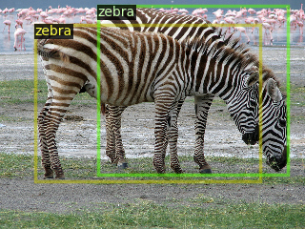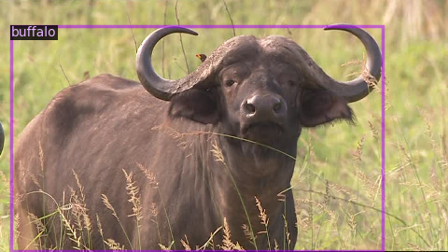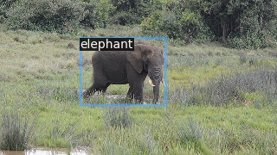

Annotation File example:
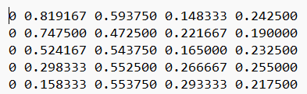

Features
The annotation files come in YOLO format with the following features:
- Class ID
- X-coordinate of the center of the object relative to width of the image
- Y-coordinate of the center of the object relative to height of the image
- Width of the object relative the width of the image
- Height of the object relative to the height of the image
Relative measurement means ratios. For example, if the X-cord of the center of the object is at 500px and the width of the image is 1000px we get a value of 500/1000 = 0.5 as the second feature in our annotation file.
Each line in an annotation file is a record for one animal in the image.

Methodology
- Preprocessing
For our project, we have trimmed the dataset to only use 753 images total split as follow:
{'buffalo': 189, 'elephant': 191, 'rhino': 186, 'zebra': 187}
After trimming a number of images from the dataset, we split and reorganized the images and annotation files in a new file structure as follow:
- animalsDataset
  - train
    - imgs: contains the images from all classes for training.
    - anns: contains the annotation files of the images.
  - eval
    - imgs: contains the images from all classes for validation.
    - Anns: contains the annotation files of the images.

- Classifiers:
Faster R-CNN is a two-stage object detection model that consists of a region proposal network (RPN) and a detection network. The RPN generates region proposals and the detection network takes those proposals and classifies and refines them. It uses a shared convolutional backbone network to generate features, which are then fed into the RPN and detection network. Faster R-CNN is known for its high accuracy and is widely used for object detection in various applications.
Mask R-CNN extends Faster R-CNN by adding a branch to generate a segmentation mask for each region proposal. The mask branch is a fully convolutional network that takes the features generated by the shared backbone network and produces a binary mask for each region proposal. Mask R-CNN is useful for tasks that require instance segmentation, where the goal is to not only detect objects in an image but also segment each object at the pixel level.

- Design of Experiments—Data Division (Training/Testing)

As mentioned in the preprocessing section, we have split the dataset into training and testing with a total of 753 images for training split as follow:

{'buffalo': 189, 'elephant': 191, 'rhino': 186, 'zebra': 187}

And 40 images for validation/testing split as follow:

{'buffalo': 40, 'elephant': 40, 'rhino': 40, 'zebra': 40}

In this dataset we have the following instances (The actual object not images) distribution:
| category | #instances | category | #instances | category | #instances
|:----------:|:-------------|:----------:|:-------------|:----------:|:-------------|
| buffalo | 257 | elephant | 399 | rhino | 262 |
| zebra | 440 | | | | |

Total: 1358

- Evaluation Metrics
Average Accuracy of the bounding box are used as main evaluation metrics.
- Results (Tables/graphs)

- Faster R-CNN
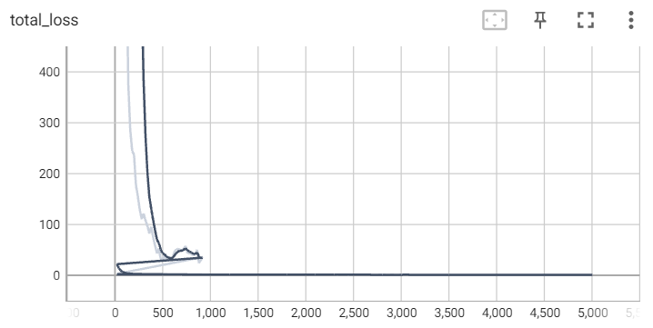
For 5000 epochs, with a learning rate of 0.000005

This model got an AP of 40.4%, with a Per-category AP as follow:

| category | AP | category | AP | category | AP |
|------------|--------|------------|--------|------------|--------|
| buffalo | 43.117 | elephant | 40.971 | rhino | 30.779 |
| zebra | 46.747 | | | | |

- Mask R-CNN:
For 1500 epochs, using a Learning rate of 0.001
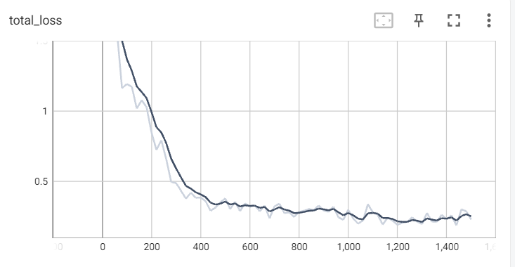
This model got an AP of 77.661%, with a Per-category AP as follow:
| category | AP | category | AP | category | AP |
|:-----------|:-------|:-----------|:-------|:-----------|:-------|
| buffalo | 83.031 | elephant | 78.650 | rhino | 79.833 |
| zebra | 69.131 |

- Analysis of the results

Comparing the results of the two models, we can see that the Mask R-CNN model has significantly better performance than the Faster R-CNN model.
The Faster R-CNN model achieved an overall AP of 40.4%, while the Mask R-CNN model achieved an overall AP of 77.661%. This means that the Mask R-CNN model is able to detect and localize objects much more accurately than the Faster R-CNN model.
Looking at the per-category AP, we can see that the Mask R-CNN model outperforms the Faster R-CNN model in all categories. The Buffalo category had the highest AP for both models, but the Mask R-CNN model achieved a higher AP of 83.031% compared to the Faster R-CNN model's 43.117%. Similarly, for the elephant, Rhino, and Zebra categories, the Mask R-CNN model achieved higher APs than the Faster R-CNN model.

Overall, it seems that the Mask R-CNN model is the better-performing model and would be the preferred choice for object detection and localization tasks. However, it's important to note that the training time for the Mask R-CNN model was only 1500 epochs compared to the Faster R-CNN model's 5000 epochs, which could affect the results. Additionally, the choice of learning rate can also have a significant impact on the performance of the models.

Conclusion
- Discuss any limitation:
In some instances, the model still gets confused by the colors and sizes of shapes and might predict an object as an animal if it resembles the size and color as we see in this image where it confused that boulder with an elephant.
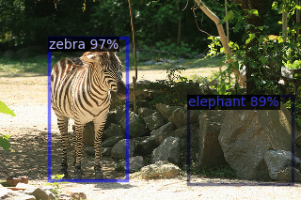
- Discuss any issue not resolved: No apparent issues.
- Future Direction:
We might add more predictors to the project and use different methods of optimization, starting with cross-validation and fine-tuning parameters like the learning rate in order to achieve higher accuracy.

Appendix
- Snapshots and others:
Results:
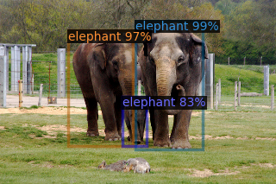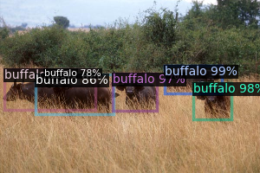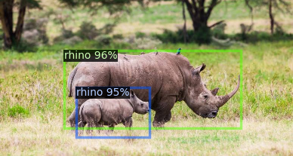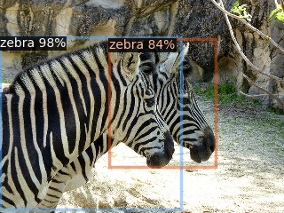

References
[1] “Getting Started with Detectron2.” Getting Started with Detectron2 - detectron2 0.6 Documentation, detectron2.readthedocs.io/en/latest/tutorials/getting_started.html.
[2] Ferreira, Bianca. “African Wildlife.” Kaggle, 25 May 2020, www.kaggle.com/datasets/biancaferreira/african-wildlife.

